### Assignment-docker – module 3



Solution:

Steps:

1. Cd /home/ubuntu/Docker/
2. Git clone <https://github.com/hshar94/helloworld>
3. Cd helloworld
4. Vi Dockerfile

FROM ubuntu:18.04

RUN apt-get update

RUN apt-get upgrade -y

RUN apt install apache2 -y

COPY . /var/www/html/

ENTRYPOINT apachectl -D FOREGROUND

ENV name SAARIT

1. docker build . -t apache_docker
2. docker run -it -p 80:80 -d apache_docker
3. curl localhost:80
4. 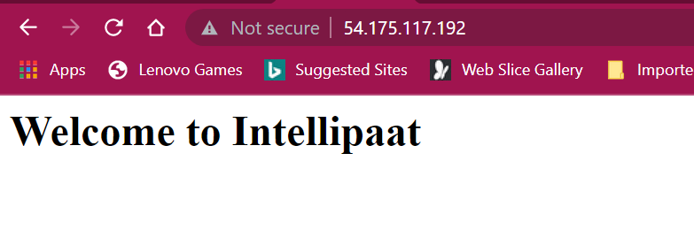
5. 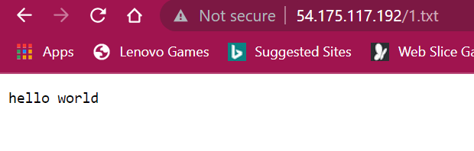
6. 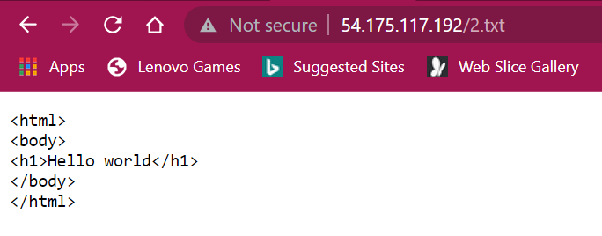
7. 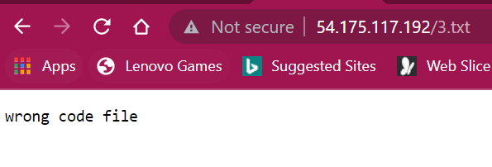
8. docker commit 37a38ce25db0 448555/dockerassignment
9. docker push 448555/dockerassignment
10. <https://hub.docker.com/repository/docker/448555/dockerassignment>
11. docker pull 448555/dockerassignment:latest